

**Enhanced PPE Precautions**

**For residents NOT UTD with COVID vaccine *or* recovered in the last 90 days AND on units**

**WITH COVID cases in the last 14 days**

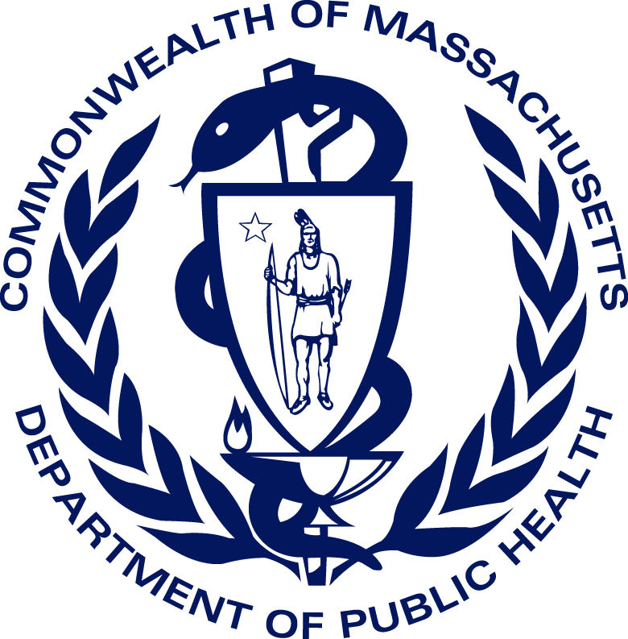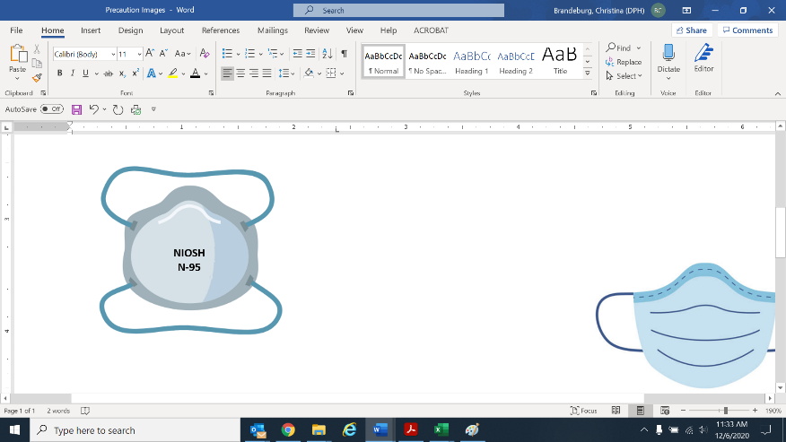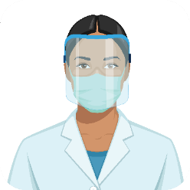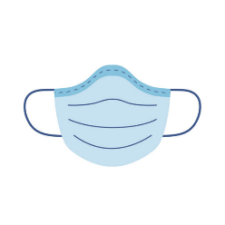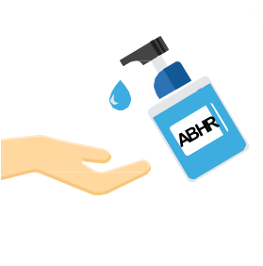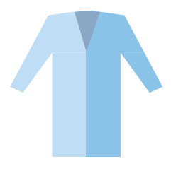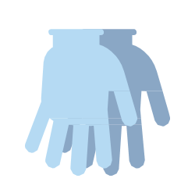

**High-Contact Care\***

N-95 for aerosol-generating procedures or ongoing transmission on unit

*Examples of high-contact resident care activities:

* Dressing
* Bathing/showering
* Transferring
* Providing hygiene
* Changing linens
* Changing briefs or assisting with toileting
* Device care or use: central line, urinary catheter, feeding tube, tracheostomy/ventilator
* Wound care: any skin opening requiring a dressing

Updated: 1/25/2022

**✓**

**✓**

**High-Contact Care\***

**✓**

**Eye protection**

(goggles or face shield)

for patient care encounters

**Mask**

**Gloves -** Change between each resident

**Clean hands:** when entering & exiting

**Gown -** Change between each resident