

**ISOLATION**

**DROPLET/CONTACT**

**PRECAUTIONS**

**In addition to Standard Precautions**

**Staff and Providers MUST:**

**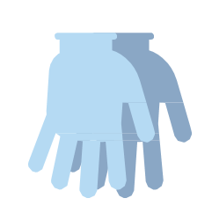******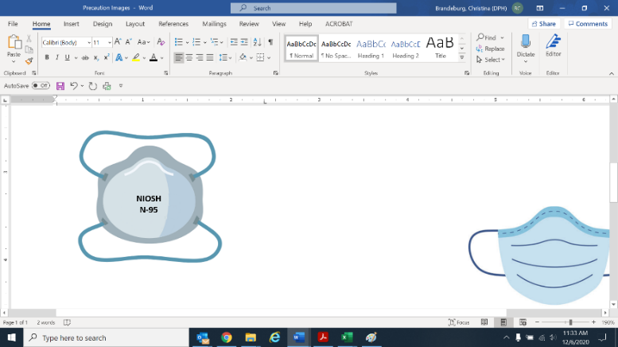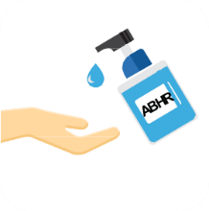

**Use patient dedicated or disposable equipment.**

**Clean and disinfect shared equipment.**

**KEEP DOOR CLOSED**

(Unless safety concern or not on physically separate unit)

**✓**

**✓**

**✓**

**✓**

Updated: 1/4/2022

**✓**

**Eye protection**

(goggles or face shield)

**N95 Respirator**

(Facemask acceptable if N95 not available;

fit tested N-95 or higher required for AGPs)

**Gloves -** Change between each resident

**Clean hands:** when entering & exiting

**Gown -** Change between each resident